**Credit Card Payment System:-Login Procedure**

**Step 1: Creating a database in PostgreSQL**

Creating a database we want all our data to be stored by using the Create Command .

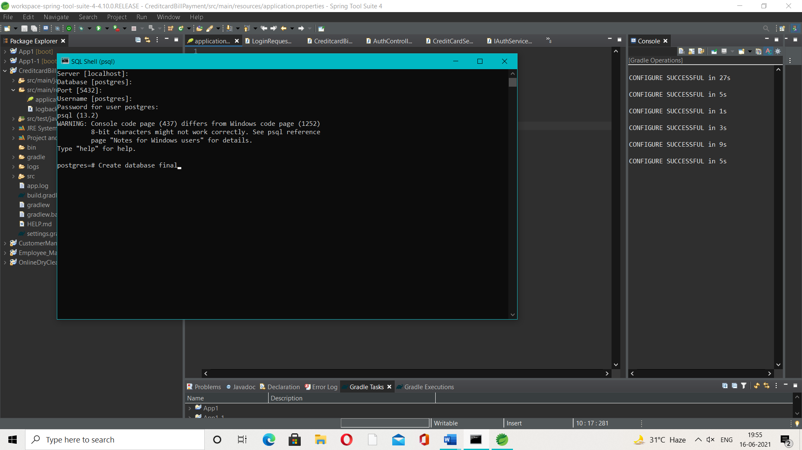

**Step 2: Running the backend module with database name , port and PostgreSQL password in the application properties file .**

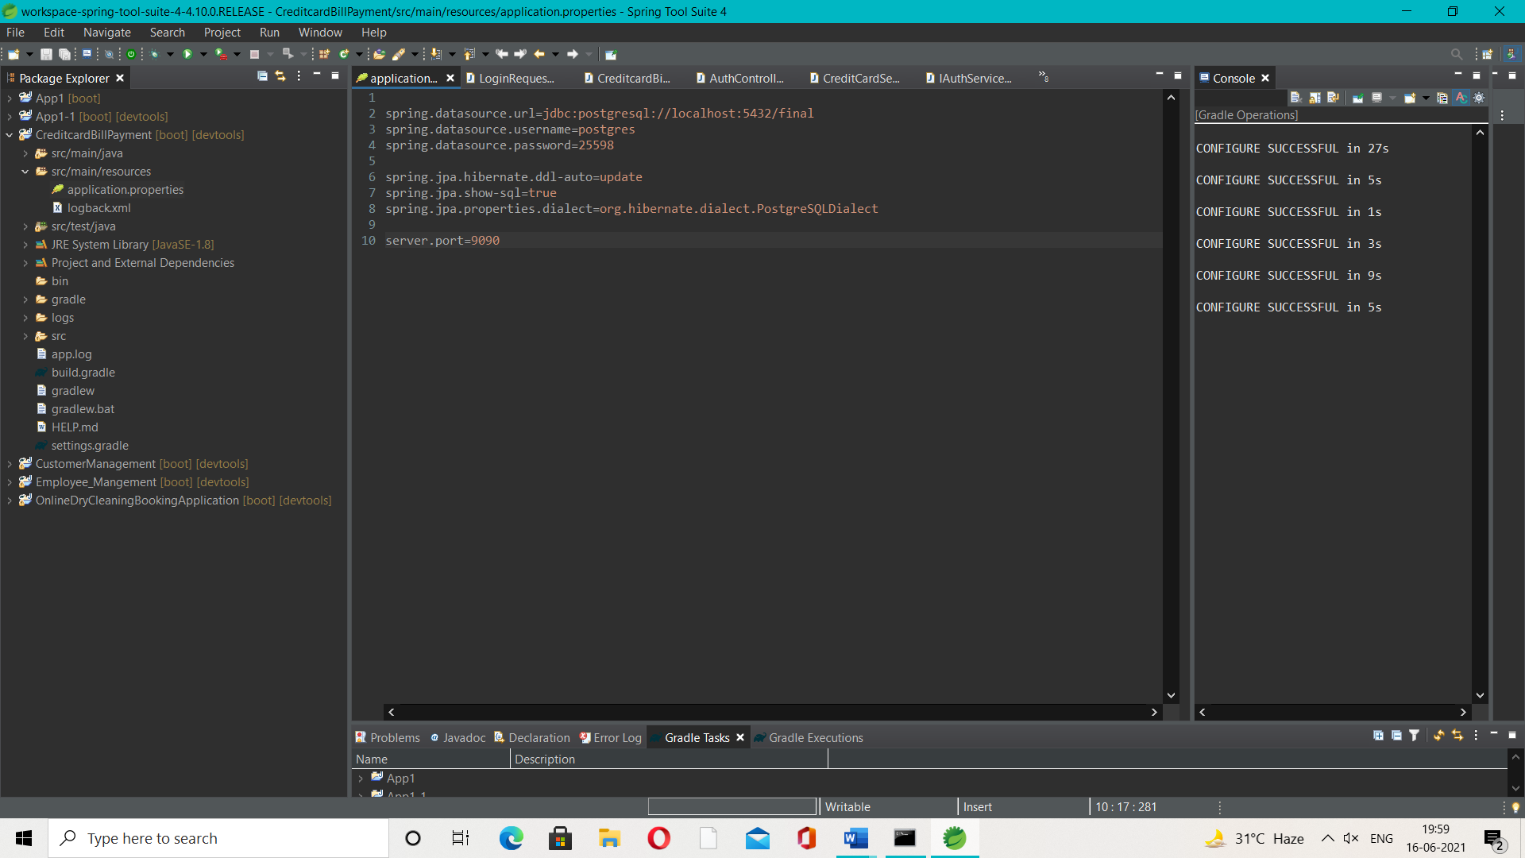

On successful run all the entities are formed as tables in the database which can be connected by **“\c database_name”** command and then **“\dt “** to check the details.

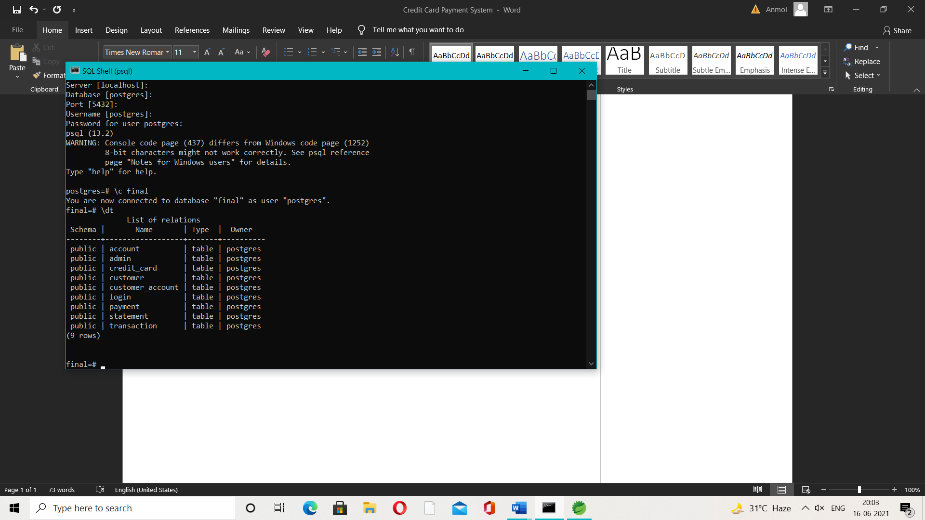

**Step 3: Inserting the values into the tables**

We enter the data in table using following command –

“Insert into Table name values (column 1, column 2,…. Nth column);

Eg:

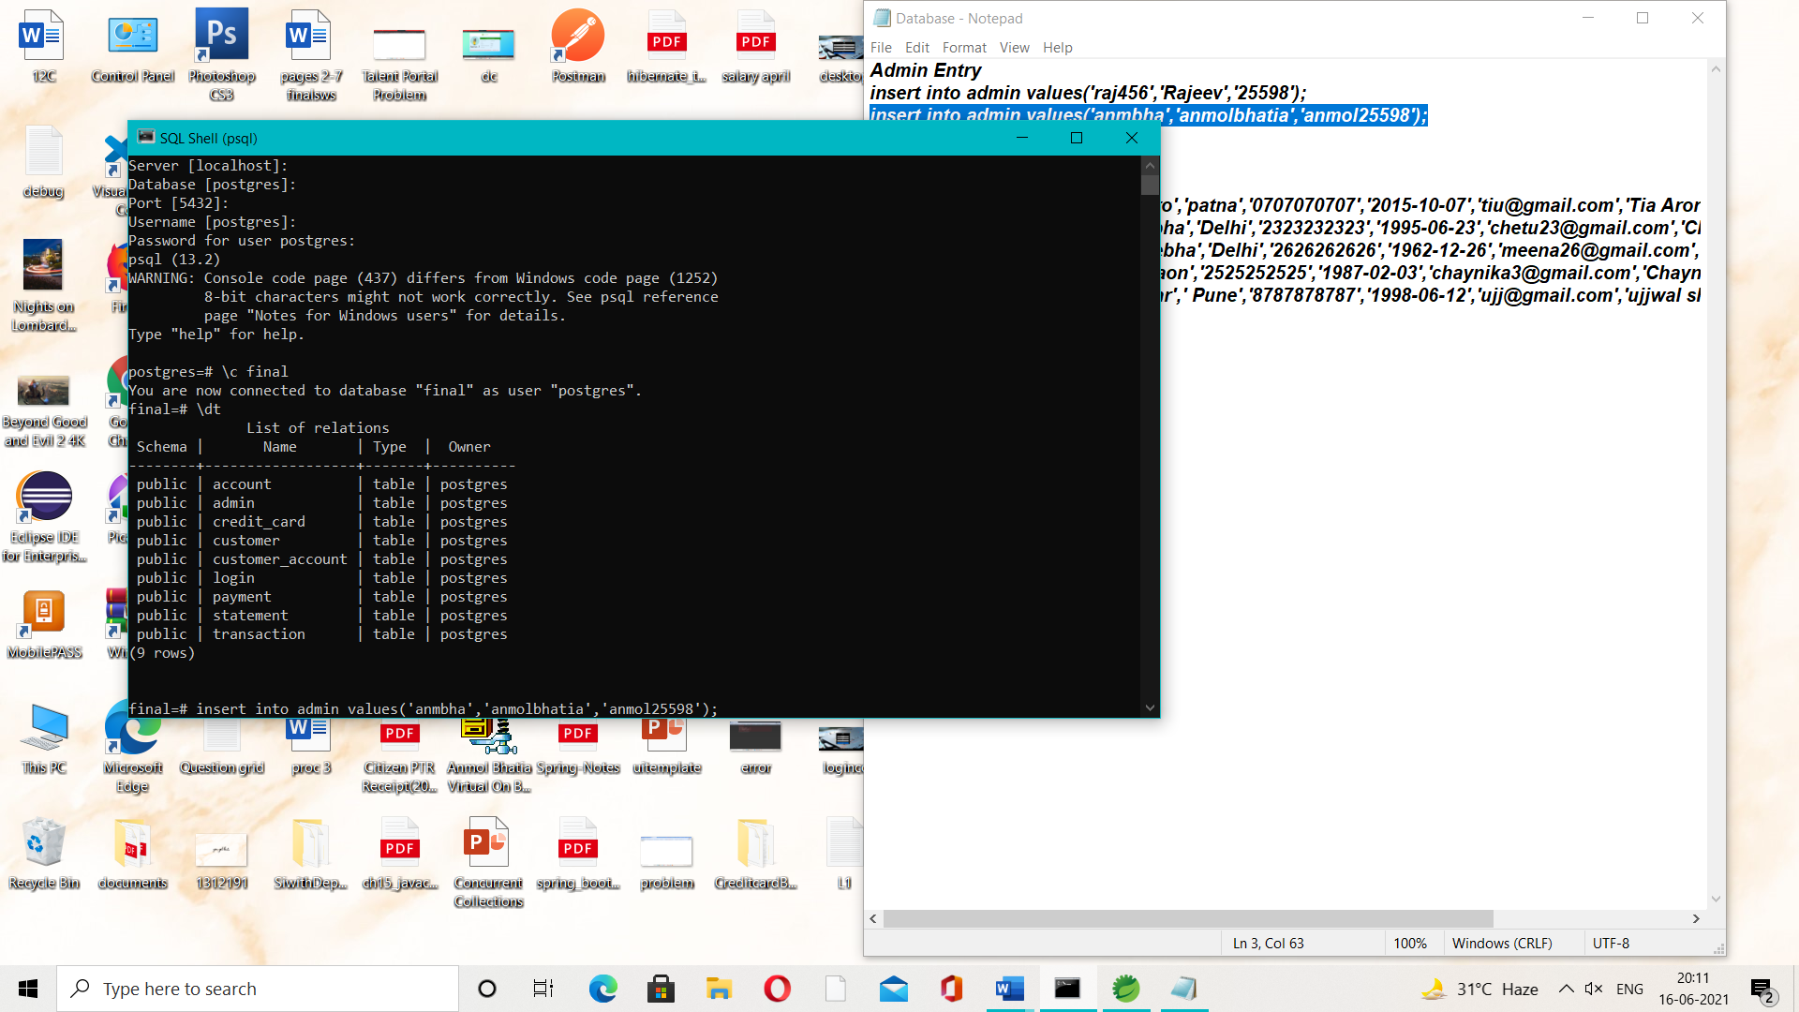

We used

**Admin Entry**

*insert into admin values('raj456','Rajeev','25598');*

*insert into admin values('anmbha','anmolbhatia','anmol25598');*

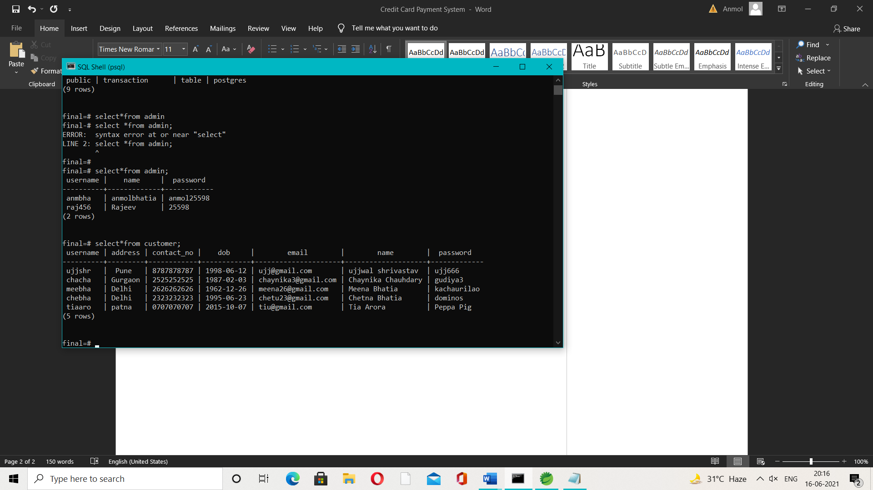

**Customer Entry**

*insert into customer values('tiaaro','patna','0707070707','2015-10-07','tiu@gmail.com','Tia Arora','Peppa Pig');*

*insert into customer values('chebha','Delhi','2323232323','1995-06-23','chetu23@gmail.com','Chetna Bhatia','dominos');*

*insert into customer values('meebha','Delhi','2626262626','1962-12-26','meena26@gmail.com','Meena Bhatia','kachaurilao');*

*insert into values('chacha','Gurgaon','2525252525','1987-02-03','chaynika3@gmail.com','Chaynika Chauhdary','gudiya3');*

*insert into customer values('ujjshr',' Pune','8787878787','1998-06-12','ujj@gmail.com','ujjwal shrivastav','ujj666');*



**Step 4: Checking of inserted values on User Interface in the backend database**

On login button click the a login request gets generated which checks within the database on the base of role selected .

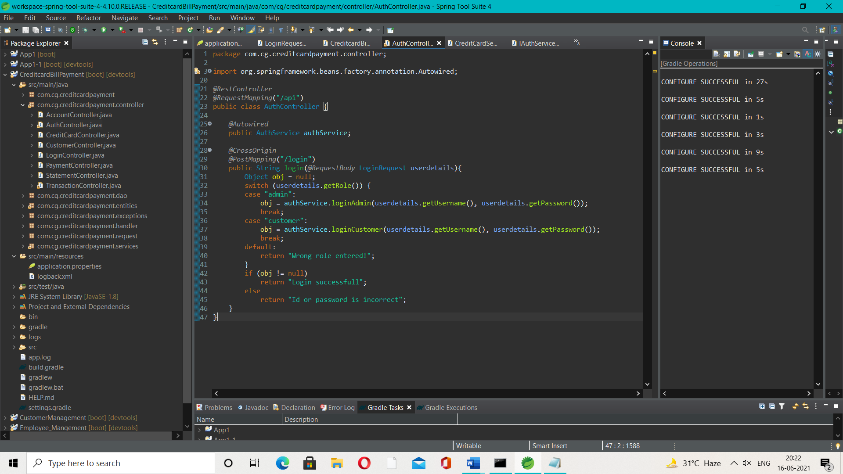

When the data entered matches the database login becomes successful.

